

Subscribe to DeepL Pro to edit this document.  
Visit [www.DeepL.com/pro](https://www.deepl.com/pro?cta=edit-document) for more information.

**Partial trolleybuses are more efficient for Košice than electric buses, say experts from abroad**

Seven lines of the Košice public transport were analysed.

[](https://www.sme.sk/aut/474/peter-jabrik)

[Peter](https://www.sme.sk/aut/474/peter-jabrik) Jabrik

Senior News Editor

Subscribe to author

follow_topic_tooltip_text

[
Parciálna linka 352 v holandskom Arnheme - trolejbus využíva na dobíjanie batérií 6,5-kilometrový úsek trolejbusovej siete, zvyšok trate potom prejde mimo trolejov. 
](https://m.smedata.sk/api-media/media/image/sme/8/89/8950468/8950468_1200x.png?rev=4)Partial line 352 in Arnhem, the Netherlands - the trolleybus uses a 6.5-kilometre stretch of the trolleybus network to recharge its batteries, the rest of the line then runs off the trolleybus tracks. (Source: Mikołaj Bartłomiejczyk)

Font:A |A-+ [discussion (0](https://kosice.korzar.sme.sk/diskusie/5362985/pre-kosice-su-efektivnejsie-parcialne-trolejbusy-ako-elektrobusy-tvrdia-odbornici-zo-zahranicia.html))

Share

[ Receive **Korzár's daily newsletter** with a summary of the day's essential news.

Top of Form



Turn on your subscription with one click. Turn on one-click subscription.

Bottom of Form

[See also the full range of our newsletters.](https://profil.sme.sk/e-maily?rtm_source=remp_campaign&rtm_medium=inline&rtm_campaign=a565b092-317e-452b-ad3a-c5ebfbb66f8b&rtm_content=f57b1662-665d-49c7-84f6-a495da60679f&rtm_variant=cdc6d988-1983-428d-85db-e8d793bd3768) ]

KOSICE. Long-standing discussions about whether we will ever see the return of trolleybus transport to Košice after its closure in January 2015 under the mayoralty of [Richard Raši](https://www.sme.sk/os/3/richard-rasi) (then [Smer](https://www.sme.sk/ps/1/smer-sd), now Hlas), should have been finally resolved by the Feasibility Study for Transport Projects of the City of Košice from the work of the Košice-based Sidin eserocky.

[Turn off advertising](https://predplatne.sme.sk/predplatne-premium-bez-reklamy?ref=static_buttonnoads_kosice)

[Turn off advertising](https://predplatne.sme.sk/predplatne-premium-bez-reklamy?ref=static_buttonnoads_kosice)

Article continues below the video ad

[Turn off advertising](https://predplatne.sme.sk/predplatne-premium-bez-reklamy?ref=static_buttonnoads_kosice)

Article continues below the video ad

Their return was promised by Raši's successor [Jaroslav Polaček](https://www.sme.sk/os/1841/jaroslav-polacek) (independent) even before his first election at the end of 2018.

As a result of the study, although de jure the trolleybuses have not been depreciated, de facto they are still not foreseen in the long term due to the alleged extremely high initial costs for the renewal of the infrastructure (trolleys, converter stations...).

[Turn off advertising](https://predplatne.sme.sk/predplatne-premium-bez-reklamy?ref=static_buttonnoads_kosice)

These are currently valued at between 15 and 20 million euros, while the former Director General of the Košice City Transport Company (DPMK), Vladimír Padyšák, spoke of only three million euros a few years ago.

[
Parciálna linka 352 v holandskom Arnheme - trolejbus využíva na dobíjanie batérií 6,5-kilometrový úsek trolejbusovej siete, zvyšok trate potom prejde mimo trolejov. 
](https://kosice.korzar.sme.sk/g/232568/buducnost-parcialnych-trolejbusov-v-kosiciach?gref=strm_art-23420334&photo=p8950468)[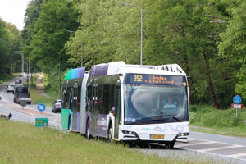](https://kosice.korzar.sme.sk/g/232568/buducnost-parcialnych-trolejbusov-v-kosiciach?gref=strm_art-23420334&photo=p8950622)[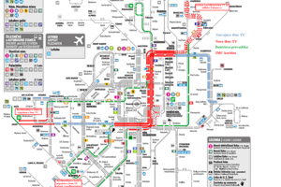](https://kosice.korzar.sme.sk/g/232568/buducnost-parcialnych-trolejbusov-v-kosiciach?gref=strm_art-23420334&photo=p8950523)

[**The future of partial trolleybuses in Košice** (4 photos)](https://kosice.korzar.sme.sk/g/232568/buducnost-parcialnych-trolejbusov-v-kosiciach?gref=strm_art-23420334)

The authors of the study found electric buses and fleet renewal in combination with CNG-powered buses to be the most advantageous. It is worth noting that this practically follows the real steps of the transport company, which has already tendered for new electric buses and is in the process of procuring CNG buses.

Two experts from outside our borders have spoken out and dispute the conclusions of the study because, in their opinion, it did not take into account partial trolleybuses, but only conventional ones.

They also provided Korzar with their joint expert text, in which they explain why it is more efficient in the long term for public transport in Košice to choose the route of partial trolleybuses.

[Turn off advertising](https://predplatne.sme.sk/predplatne-premium-bez-reklamy?ref=static_buttonnoads_kosice)

[Related article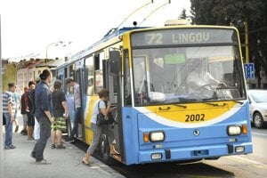 Related article Raši stopped them, Polaček promised to return. The study didn't completely write off the trolleybuses, but it didn't help them either Read more](https://kosice.korzar.sme.sk/c/23403506/rasi-ich-stopol-polacek-slubil-navrat-studia-trolejbusy-celkom-neodpisala-ale-ani-im-nepomohla.html?ref=av-center)

**They have used their own experience from other projects**

One of the pair is Mikołaj Bartłomiejczyk. He is an associate professor at the Faculty of Electrical Engineering and Automation at the Technical University of Gdansk (Poland), currently on a research fellowship at the Technical University of Delft in the Netherlands. He also works at PKT Gdynia (local transport company) and at the Faculty of Economics, University of Gdansk. His research interests include electric traction, urban electric transport and electromobility.

The second is Professor Pavol Bauer, originally from Košice, who studied electrical engineering at the Technical University in Košice, but has lived abroad for many years. Since 2016, he has been a full professor at the Technical University of Delft, where he also received his Ph.D. in 1995. There he is the head of the department focused, among other things, on electromobility research at the Faculty of Electrical Engineering, Mathematics and Computer Science. He also holds the highest scientific and pedagogical rank of professor from the Brno University of Technology (2008) and from the University of Timisoara, Romania (2018), where he also holds an honorary doctorate (2022).

[Turn off advertising](https://predplatne.sme.sk/predplatne-premium-bez-reklamy?ref=static_buttonnoads_kosice)

"In the past we have been looking at sustainable energy sources for transport and one of the project tasks we have tackled was the trolleybus network in Arnhem in the Netherlands - for example, charging electric cars from the trolleybus network, powering the network from photovoltaics, using flashlights, etc. We have gained experience in solving this task, which we would like to use in the design of public transport in Košice," said Professor Bauer.

The results of the study commissioned by the city of Košice were described as, one could say, neutral.

"An important element that has not been considered so far, however, is the possibility of using In Motion Charging (IMC) technology, colloquially known as 'partials'. These are trolleybuses equipped with batteries that are charged from the trolleybus network while the vehicle is in motion for use off the tracks. This makes it possible to develop trolleybus transport without the need for significant expenditure on expanding the catenary network, or at a much lower cost than for conventional trolleybuses," the pair of experts describe.

In their text for Korzár, they therefore mention the possibility of developing trolleybus transport using battery trolleybuses, which will enable its significant development.

"Increasing the number of vehicles in use will allow better use of the infrastructure, which will also improve the economic efficiency of the system. Our abbreviated analysis was based on the previous experience of TU Delft and the University of Gdansk in the field of urban electric transport, as well as the experience of the Gdynia Transport Company," they say.

[Related Article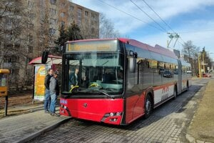 Related Article They say they didn't write off trolleybuses, but are only going to buy electric buses. They also argue Volvo Read](https://kosice.korzar.sme.sk/c/23298236/tvrdia-ze-trolejbusy-neodpisali-ale-idu-nakupovat-iba-elektrobusy-argumentuju-aj-volvom.html?ref=av-center)

**They point to expensive batteries as a weakness of electric buses**

They draw attention to exactly what the municipality of Košice is going to do by preferring electric buses.

"Cities and transport companies are often driven by the desire to get results as quickly as possible when buying electric buses. That's why they often buy buses with large traction batteries that allow for significant range and minimize infrastructure costs. However, this approach may prove to be wrong in the long run due to the cost of replacing traction batteries over the lifetime of the vehicle," they warn.

They highlight a very important factor, which is the increasing need for batteries in electric buses, and link it to both electromobility and the limited raw material resources in the world.

Simply put, the "partials" as an alternative have smaller batteries (kWh) even than the popular Tesla passenger car and "only need a 'slice' of the trolleybus network to charge them".

The experts from the Technical University in Košice, who drew up an expert opinion on the future of urban transport, were very well prepared, even according to our opponents, but they did not pay attention to such a very important matter as the development of trolleybus technology.

"If the cost of renewal and maintenance of the existing trolleybus infrastructure in Košice for only fifteen vehicles (lines 71 and 72 - ed. note) can be considered as an obstacle to maintaining this form of transport, the possibility of its development on the basis of modern technologies puts the Košice trolleybuses in an incomparably better light," state experts from abroad.

According to them, if we want to discuss the future of trolleybuses in Košice, we should think not only about the existing trolleybus lines 71 and 72, but also about the possibility of significant development of other lines using the existing infrastructure and the so-called partial trolleybuses.

"This is the 'game changer' that makes trolleybus transport more attractive compared to the published study," they explain.

The "partials" are equipped with batteries that allow operation off the overhead contact line. This means that they travel part of the route as trolleybuses, while at the same time recharging the batteries, and then continue driving off the tracks as an electric bus.

"On the other hand, if we want the battery bus to have a long enough range, we need high-capacity batteries in electric buses. And that carries a big burden. What's more, the lifetime of the batteries is usually seven years or less, so they need to be replaced. And they currently cost around 150 thousand euros per vehicle," the experts state.

As they go on to say, we can be optimistic and hope that the price of batteries will fall, but on the other hand, the demand for batteries is increasing globally, which may prevent their prices from falling.

"In addition, the weight of batteries in electric buses can be up to several tonnes, which means we have to carry batteries instead of passengers... And compared to conventional trolleybuses, only part of the route has to be equipped with a catenary, so the infrastructure costs are much lower than for conventional trolleybuses."

It is also true, according to them, that batteries must be used in partial trolleybuses.

"But unlike electric buses, we also have regular overhead line charging, which allows for a much lower battery capacity and the choice of better technology, such as LTO, which has a fifteen-year life."

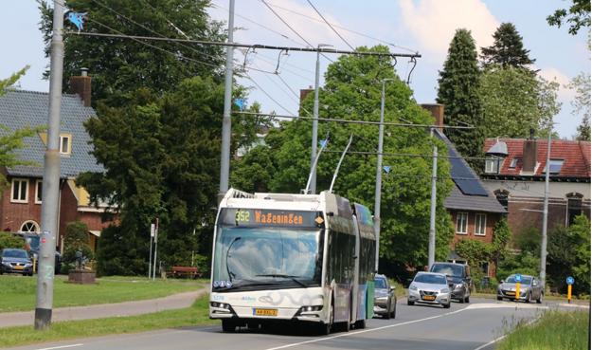Partial line 352 in Arnhem, the Netherlands - the trolleybus uses a 6.5-kilometre section of the trolleybus network to recharge its batteries, the rest of the line then runs off the trolleybus tracks. (source: Mikołaj Bartłomiejczyk)

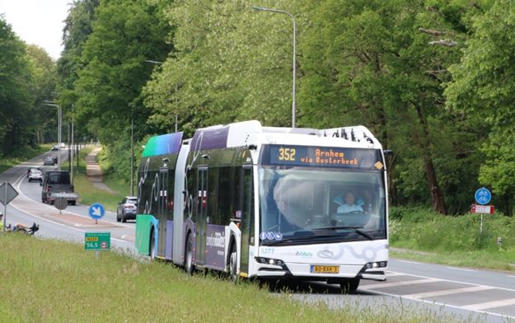Partial line 352 in Arnhem, the Netherlands - after leaving the trolleys, the trolleybus travels 13 kilometres to the nearby town of Wageningen thanks to batteries. (Source: Mikołaj Bartłomiejczyk )

**An interesting example is the city of Arnhem**

They argue that the number of transport systems using trolleybuses is now steadily increasing.

"One of the many interesting examples is the Dutch city of Arnhem, where in May this year partial trolleybuses started to serve the intercity line 352. The trolleybuses use a 6.5 km long section of the existing trolleybus network in the city centre to recharge their batteries. This makes it possible, for example, to travel to Wageningen, 13 kilometres away, on battery power."

They point out that "partials" can also be found much closer. In fact, Prague recently launched the airport line 59, which is served by partial 24-metre mega trolleybuses, and it's the batteries that make them go to the airport.

"Another technical innovation that further enhances the capabilities of the 'Partial' are the fast charging stations that allow additional battery charging while parked. This solution was used in the Swiss city of St. Gallen, where a 200 kW fast charging station for trolleybuses was installed. This makes it possible to further combine the advantages of trolleybuses and electric buses."

Importantly, in St. Gallen, this fast charging station is fed from the existing trolleybus infrastructure - the traction converter station - by means of additional power cables.

"This took advantage of the possibility of integration with the existing traction infrastructure and avoided the need to build a new charging station. And that was the idea behind this project: to make the best use of the existing infrastructure for the development of trolleybus transport. This can also be done in Košice, where there is an extensive tram network in addition to the trolleybus network, which could also be used for the development of trolleybuses."

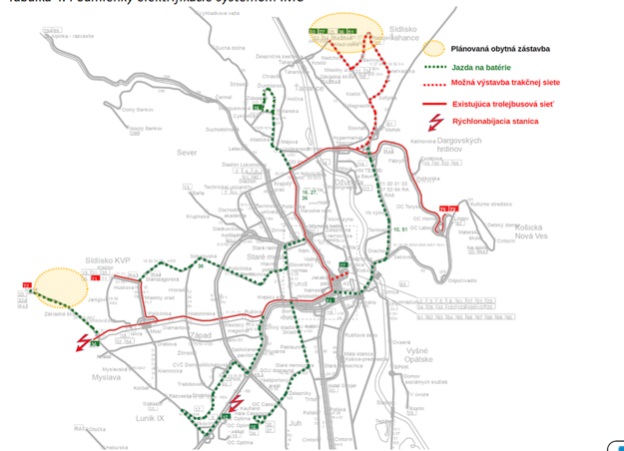Schematic of the proposed IMC (partial trolleybuses) system in Košice. The new planned housing estates according to the zoning plan were also marked out. (source: Pavol Bauer, Mikołaj Bartłomiejczyk)

**Seven Košice lines are suitable for "partials"**

Bauer and Bartłomiejczyk analysed the possibilities of more efficient trolleybus transport in Košice compared to the conclusions of the urban study.

They noted that trolleybus transport was launched in the metropolis of the East in 1993 on one line No. 70 connecting the Dargovské hrdinov housing estate with the city centre. After the extension of the lines from the centre to Myslava and Sídlisko KVP, lines No 71 and 72 were established, later line No 70 was cancelled.

"Despite the fact that the extent of the network of trolleybus lines in Košice was not large, trolleybuses provided up to 8 per cent of the transport and 10 per cent of the transport performance of Košice urban public transport. It is not without interest that a night trolleybus line also operated in Košice."

They recalled that in 2015 the operation of trolleybus transport was suspended, the official reason being the reconstruction of tram lines in the city centre. This also affected the trolleybus catenary.

"However, the reconstructed sections of the trolleybus line have not yet received regular trolleybus transport. The trolleybus network runs along the main communication routes of the city. Importantly, its route partly overlaps with several bus lines, such as the 16, 27 or 36. This makes it suitable for use as a charging corridor for 'partials', despite its short length," say experts.

According to them, it is extremely important that the trolleybuses in Košice are powered from a 750 volt (V) network, which allows for greater charging power than in the examples of the aforementioned 600 V networks from abroad.

In order to operate a line with "partials", it must run at least 30 to 50 percent of the route under the trolleybus network. This is the amount needed to charge the battery.

"If we look at the map of Košice, we see that we have several bus lines that meet this condition. In addition, just a slight extension of the network can already increase the possibilities of using battery trolleybuses. Even the possible construction of a network to the Ťahanovce housing estate may be justified given its mountainous nature and the route of several bus lines. This urban district currently has no electric transport."

**Standard battery life is 15 years**

In an IMC system, the key element is the battery charging power, which determines the required minimum line coverage of the catenary.

The standard solution is a charging capacity of 100 kW ("IMC standard"), which allows the line to be operated with approximately 40 to 50 percent overhead line coverage.

It is also possible to use a higher charging power of 200 kW ("IMC power", but there are also plants where batteries can be recharged with up to 350 kW), which allows the line to be operated with a lower catenary coverage of between 25 and 30 percent.

If the overhead line coverage is low, an additional charging station may be necessary.

Increasing the charging power allows the battery to charge faster, but this requires the use of a larger on-board charger (called an On Board Charger) and reduces battery life.

"LTO batteries used as standard in IMC systems have a lifetime of 15 years, but at high charging power this can be reduced to 7 to 10 years, requiring earlier replacement."

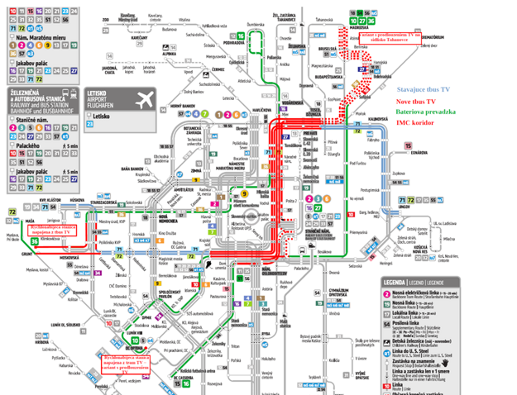Diagram of bus routes that can be electrified by the IMC system. The so-called "IMC charging corridor" forms part of the current trolleybus network that would be used to charge the batteries in the IMC trolleybuses (red lines). The section to Ťahanovce would be a battery corridor using only the existing network, but would also become an IMC charging corridor in the event of electrification (source: Pavol Bauer, Mikołaj Bartłomiejczyk ).

**They dealt with two options for a solution**

For the analysis, the pair of authors used, in addition to the original trolleybus lines 71 and 72, five bus lines 10, 16, 27, 36 and 51, which could be operated by "partials".

From a comparison of the energy and operational parameters of five lines that can be electrified with the IMC system without expanding the current trolleybus network, they found that this could be done for lines 16, 27 and 36 in addition to lines 71 and 72.

However, a fast charging station would have to be built for line 36 at the Grunt turning point in Myslava, which would be fed from the existing trolleybus network.

If the trolleybus network is extended to Sídlisko Ťahanovce, "partials" could also run on lines 10 and 51. Although the "36" would no longer need a fast charger at the Grunt turning point, it would be necessary for the "10" at the terminus near OC Optima with power supply from the nearby existing tram network.

"What is important is that both fast charging stations can be powered from the existing energy infrastructure, so it does not require the construction of a new one," the experts explain.

Only in the optimistic variant would the same number of electric buses or "partials" - 32 vehicles - be sufficient on these five lines.

"However, as numerous operational experiences show, when operating electric buses, it is necessary to provide additional vehicles in case of traffic delays that make charging at final stops difficult. Arriving late at the terminus results in shorter waiting times, which also reduces the time required for charging and may require the use of additional vehicles."

In such a pessimistic scenario, the number of electric buses would already have to be increased by one on each of the four lines - No. 10 (from 8 to 9), No. 16 and 27 (from 6 to 7) and No. 36 (from 9 to 10). Only the number of three electric buses on line No 51 would be maintained.

At the same time, let us recall that electric buses are more expensive than partial trolleybuses.

DPMK has now tendered 18-metre electric buses at 812 500 EUR without VAT per unit and the Prešov transport company has recently purchased partial trolleybuses at 666 thousand EUR per unit, which is 146 500 EUR less.

With the expected need to deploy 36 vehicles on the above-mentioned five lines in the pessimistic variant, the difference in the total price would be more than EUR 5 million to the detriment of electric buses.

**"Partials" win in the long run**

The authors of the analysis for Korzár also quantified various costs associated with the operation of electric buses and "partials".

In the case of electric buses serving the analysed lines, four charging stations need to be built at an estimated cost of €2.4 million.

"If the current trolleybus infrastructure is used for the IMC system, it is necessary to build a new exchange station in the city centre for the introduction of partial trolleybuses (EUR 1.5 million) or to use the tram substation for this purpose, to modernise the cable system or to build a new catenary network in front of the railway station and to modernise the existing one in other places (EUR 1.4 million in total)," the experts explain the necessary steps, which they have estimated at EUR 2.9 million in total.

They stressed that the infrastructure expenditure referred to above relates only to the trolleybus network needed to charge the "partials".

The financial cost of these items is necessary because the IMC trolleybuses have a much higher energy consumption due to the need for charging during the journey and the current power supply system of the trolleybus network in the central part of the city is relatively weak.

If the "partials" were also introduced for the transport service of the Ťahanovce housing estate, it would be necessary to build an additional four kilometres of new catenary network together with the construction of another new catenary converter station, which would increase the total amount from 2.9 to 5.7 million euros.

The analysis also includes a comparison of the expenditure for electric buses and "parkies", which includes the cost of their acquisition, the necessary charging infrastructure, but also the amount needed to replace the batteries in the future.

If only electric buses operated on all seven lines analysed (5 current bus lines and 2 original trolleybus lines), in the pessimistic scenario these costs would amount to more than 50 million euros.

According to the calculations of a couple of experts, providing the same service of these lines only by "partials" (four lines) or classic trolleybuses (lines No. 27, 71 and 72), including the cost of construction of new trolleys to Sídlisko Ťahanovce, comes out to an amount of 10 million less than that of electric buses.

Roughly the same amount, i.e. 40 million euros, is also the cost of the third option without overhead lines to Ťahanovce and using the current infrastructure. In this case, two lines would have to be served by electric buses (Nos. 10 and 51) and the remaining five by "partials", i.e. conventional trolleybuses.

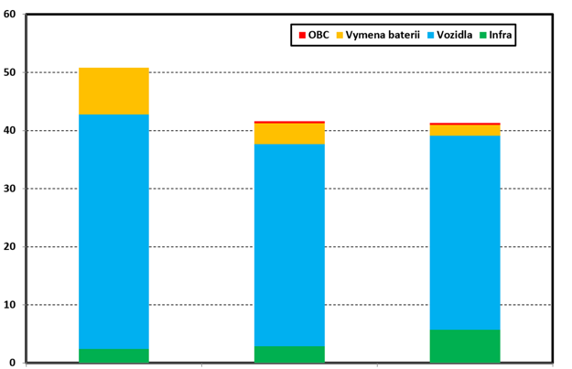Comparison of vehicle expenditure (in millions of euros) in the pessimistic variant (more electric buses than trolleybuses needed to serve 7 lines). Left column - costs when served by electric buses only. Middle column - costs with current infrastructure if 2 lines out of 7 had to be served by electric buses. Right column - cost of purely trolleybus lines after construction of trolleybuses to Sídlisko Ťahanovce. (source: Pavol Bauer, Mikołaj Bartłomiejczyk )

**The more vehicles, the more efficiency**

This result is due to the lower price of trolleybuses and "partials", the need for fewer of them than electric buses, but also to the lower cost of future replacement of the batteries of "partials", which are much cheaper than those of electric buses. In addition, they last almost twice as long with standard charging, i.e. not 7 but up to 15 years.

"The more vehicles in service, the greater the savings on them and the better the benefit of sharing the trolleybus infrastructure. Therefore, increasing the number of partial trolleybuses as replacements for the current vehicles on bus routes can significantly improve the financial attractiveness of trolleybus transport," the experts conclude.

On the other hand, they also acknowledge the need for expenditure on infrastructure renewal and maintenance.

"This is one of the barriers to restarting trolleybus transport in Košice," Bartłomiejczyk and Bauer realise.

At the same time, however, "Košice operates an extensive tram network, so there is already extensive technical provision of the trolleybus infrastructure and, in particular, the traction network service".

In addition, they explain that the modernisation of the overhead contact line network can be divided into several phases over the long term, so that investments can be made in several stages.

In the context of the well-known arguments against trolleybuses in Košice about the devastated infrastructure, foreign experts mention the functioning trolleybus system in neighbouring Prešov.

"Despite the fact that the one in Prešov is much older (launched in 1962) and many sections of the trolleybus network have been in operation much longer than the network in Košice, many of its fragments are still functioning today without major reconstruction. The oldest original route without reconstruction to Širpo is 50 years old. Even in this light, it cannot be said that the condition of the trolleybus network in Košice is catastrophic."

Therefore, they agree that with the current trolleybus network layout, the optimal solution from an economic point of view is currently to implement an IMC system using the existing infrastructure.

According to them, the cost of "partials" is also much lower in this case after taking into account the need to replace batteries and provide additional electric buses due to the issue of charging time at the terminals.

"However, in the case of an increase in transport performance or the development of the city and public transport to the north, the justification for the construction of a trolleybus network to Ťahanovce would increase even more. The argument for extending it to this location would undoubtedly also reduce the consumption of traction batteries of partial trolleybuses compared to the variant using only the currently existing trolleybus infrastructure, which would bring additional benefits in the long term."

A significant bonus would be the even more significant vehicle savings already presented compared to the electric bus.

By extension to the north they mean the planned new residential development in the Skalky housing estate, which would significantly increase the transport demand on the trolleybus route to Ťahanovce.

"There would be a need to provide connections to the city centre by large capacity vehicles. A trolleybus line with dedicated lanes for public transport vehicles would be ideal for this task. Then it is also justified to consider the use of up to 24-metre vehicles."

In the conclusion of the analysis, the authors state that the existing trolleybus network in Košice has not been used for almost ten years and requires the investment costs discussed above.

"On the other hand, due to its central axis route, it has a significant potential for the implementation of the IMC system in Košice. As we have mentioned, it is even possible to put more than 30 IMC trolleybuses into service. It should also be noted that despite the poor technical condition, the catenary network is still operational, as evidenced by the occasional trolleybus trips," concluded the pair of experts, operating beyond our borders.

Read more: https://kosice.korzar.sme.sk/c/23420334/pre-kosice-su-efektivnejsie-parcialne-trolejbusy-ako-elektrobusy-tvrdia-odbornici-zo-zahranicia.html